Login:
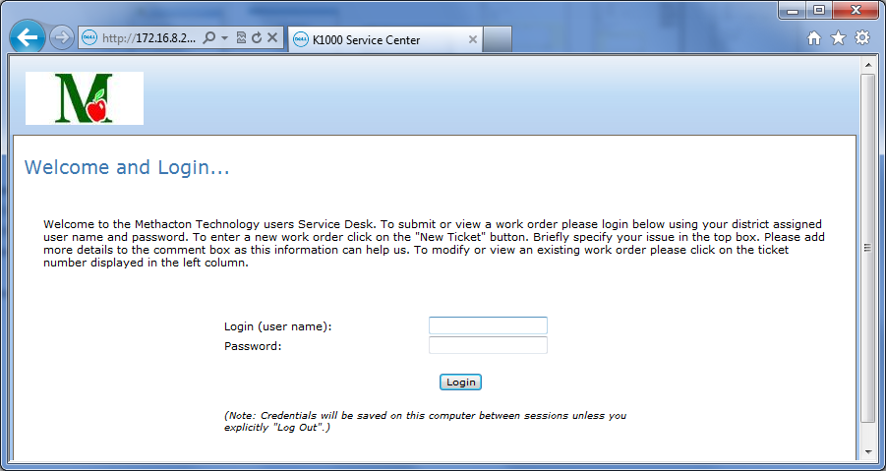
Creating new work order or viewing status of existing work orders:
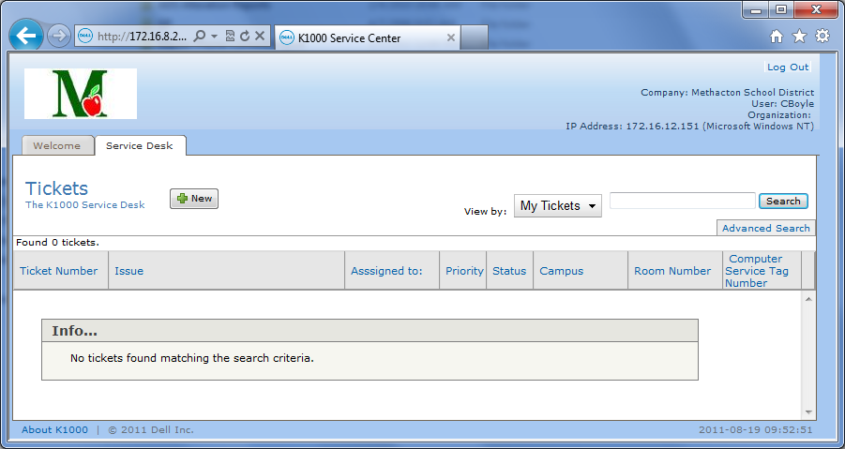

New work order creation:
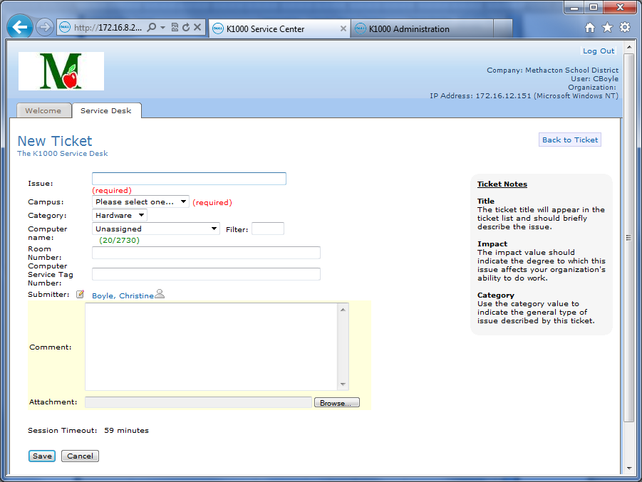
Accessing previous work orders for status review:
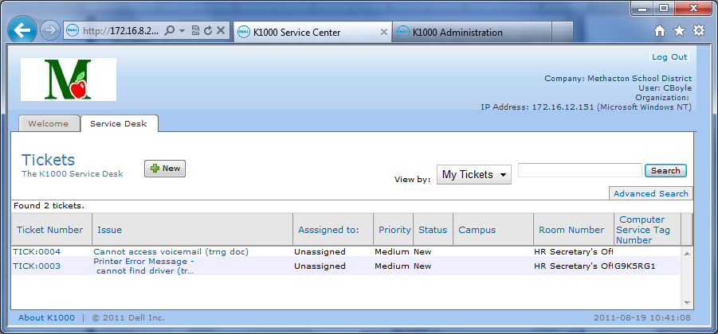
Viewing previously entered work order and option to add comments with ‘add comments’ button:
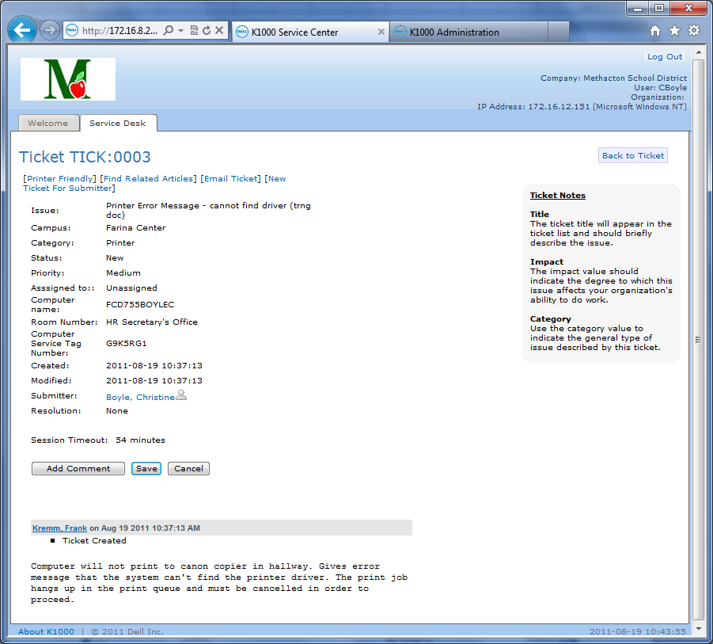

Accessing the KACE service desk via web browser:
http://172.16.8.204
http://techdesk
(Note that there is no ‘www’ in the address…accessible only inside the district)
Information we are looking for when filling out blocks in a work order:
Issue: few word description of problem (i.e., network printer not printing, projector bulb not lighting, application error on notebook, etc.)
Campus: dropdown list of buildings (most will accept a single letter input to correct/desired location)
Hardware: dropdown list of common equipment types (printer, computer, phone, etc.)
Computer name: used in conjunction with filter, type into ‘filter’ block identifying info (last name of personally assigned notebook or bldg./room identification , such as ‘hsc200’) and select appropriate machine from computer name dropdown list.
Room number: proper room number or office name
Service tag: NOT the white ‘district label’, but the silver or black manufacturer tag for the computer
Submitted by: yourself or for someone else (use this if, as office staff, you are entering a work order for another individual)…. Use filter
Comments: More complete description of issue or request (what did you see, experience or notice that led you to believe there is a problem….what do you need…who have you spoken to…etc.)
Attachments: supplemental lists, other documents, etc.
Save: button at bottom of screen document…if you don’t save, it goes away when you exit document.

